HOW TO DOWNLOAD VIDEOS FROM EARTHCAM

This is instructions for downloading archived data (1 hour- 3 days old) from the Earthcam website. These are visual supplements to the existing README.

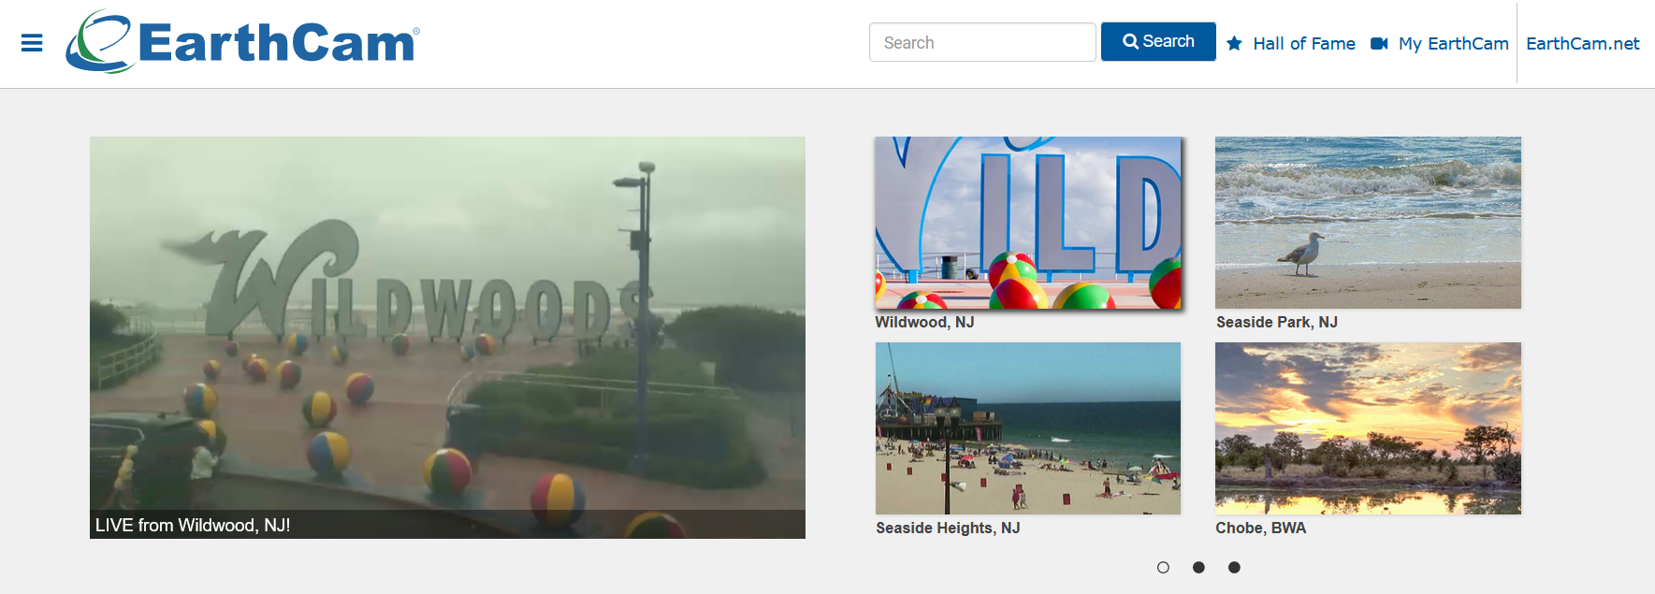

1. Find the camera you want to download. We will be using Seaside Park in NJ as an example.

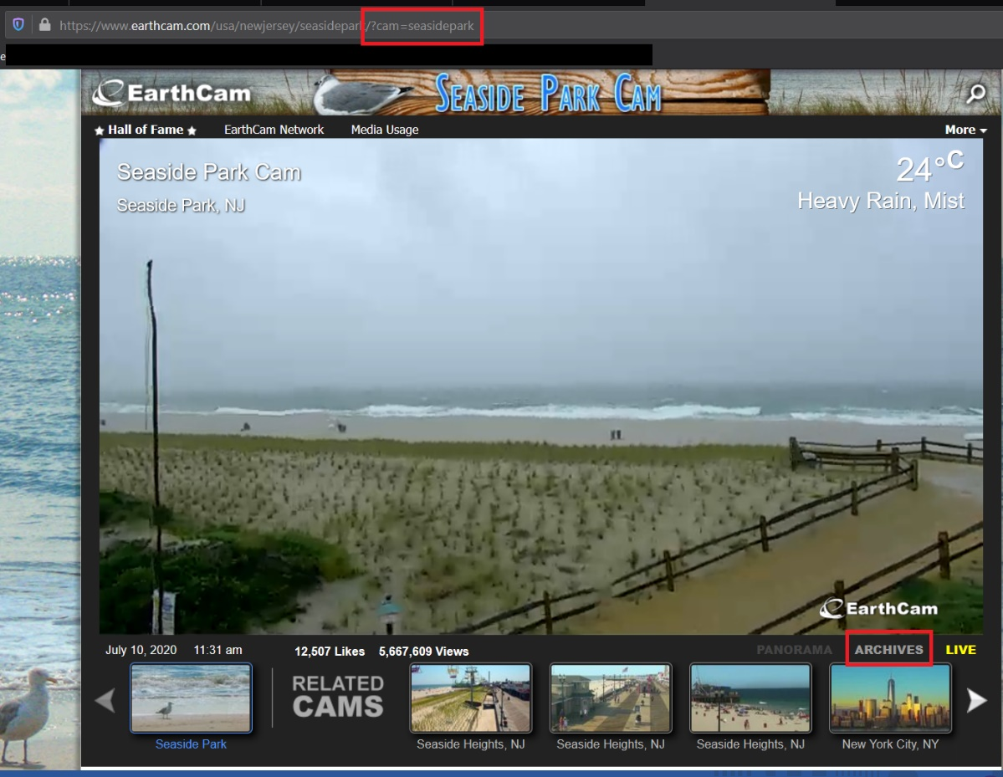

1. Note the location name in the URL. You will now click the archives button.

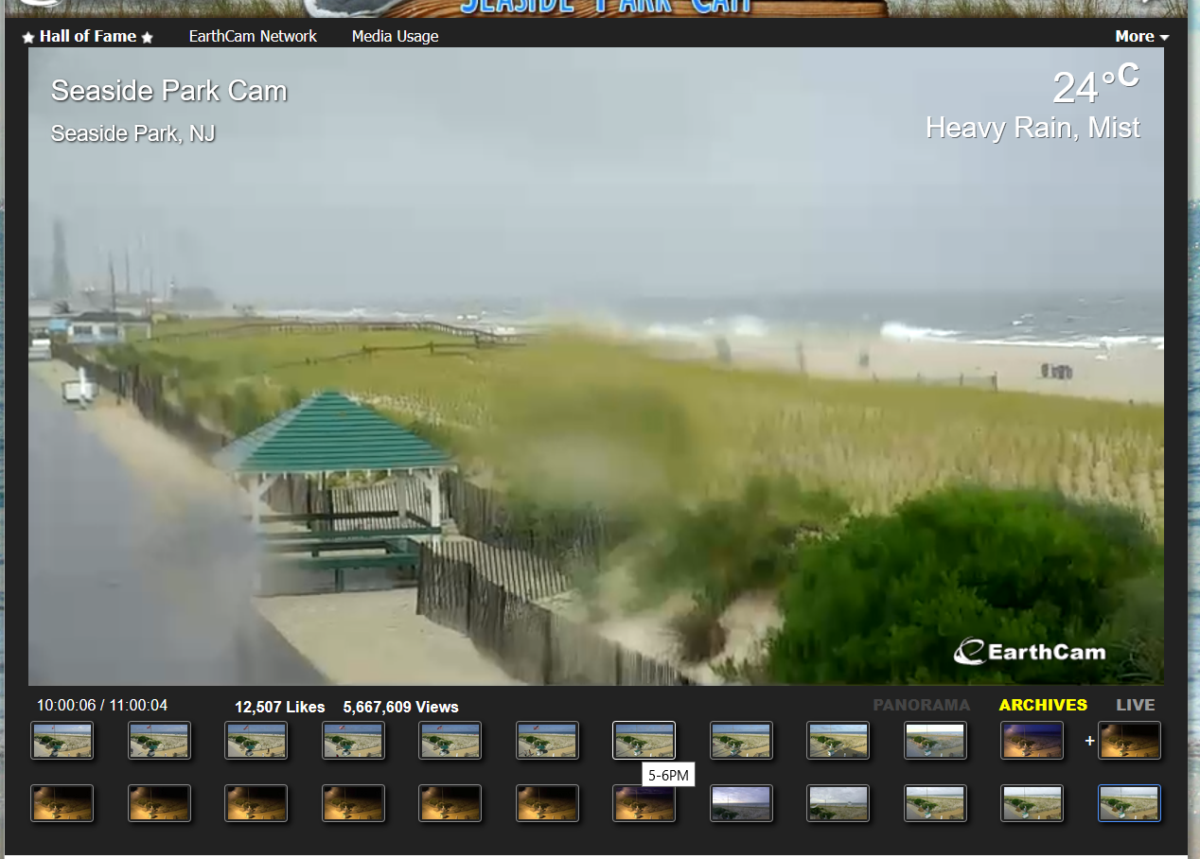

1. Hover your mouse to see what times are available. **Click on any one** – any time will do, as this is not where we specify the video times that we want.

Open the network options in your internet browser. In firefox, the shortcut is Ctrl + Shift + E.

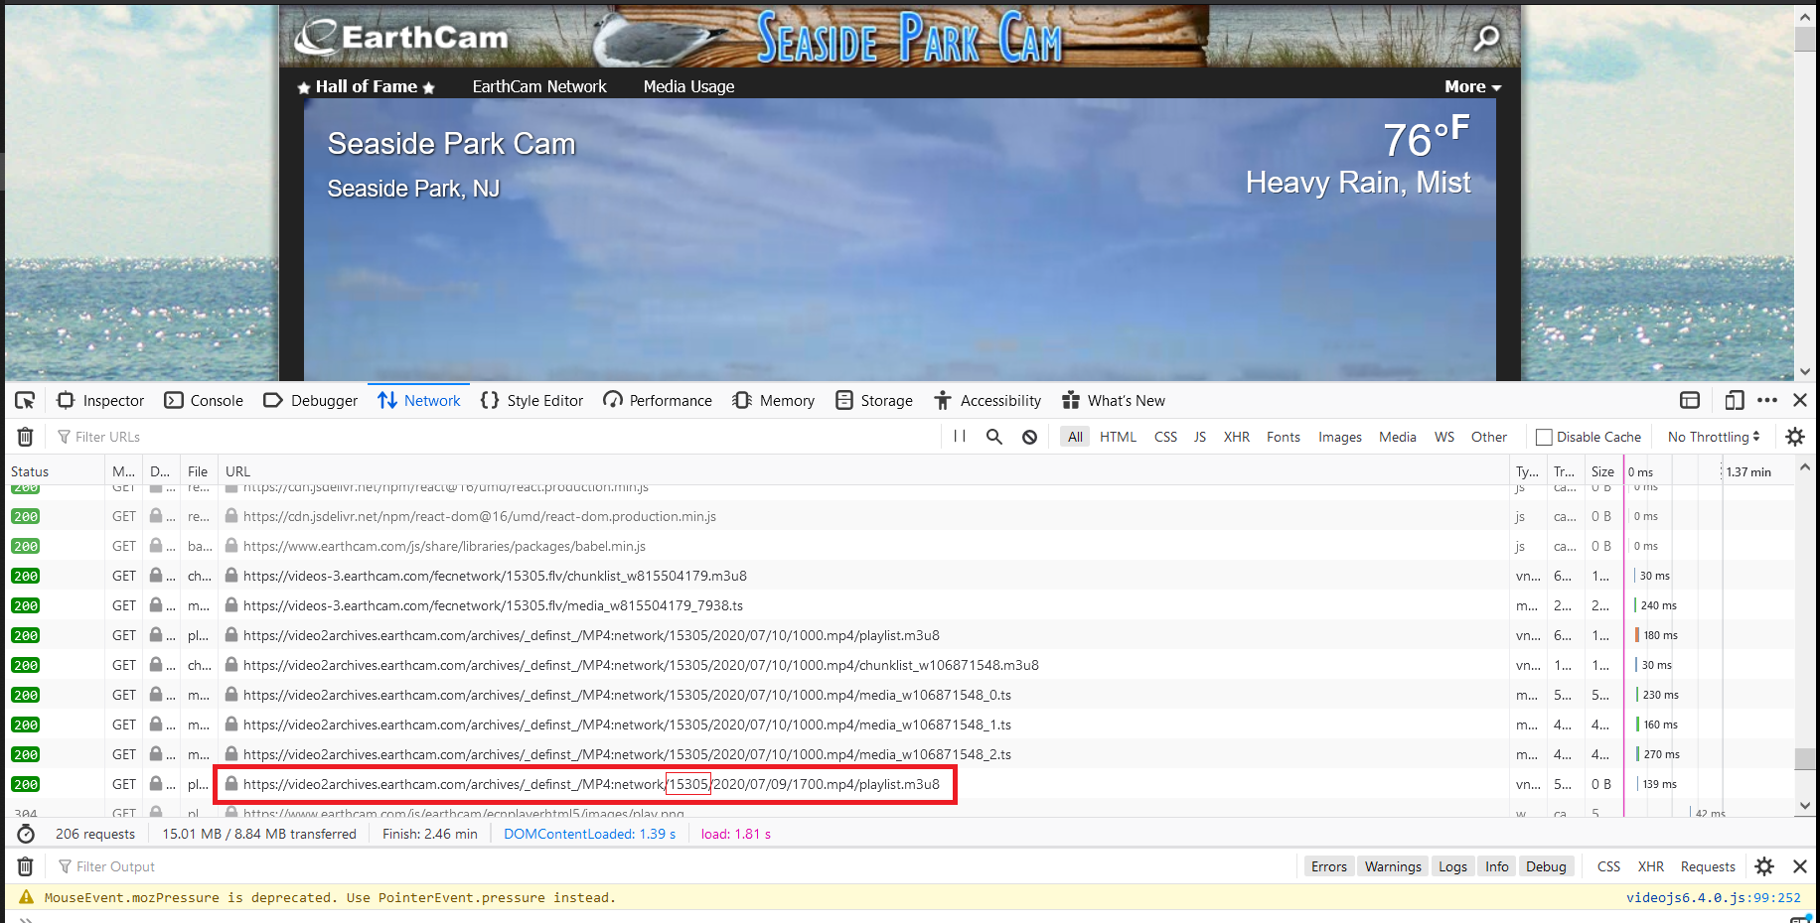

1. You may have to right click the bar that says “status” to show the URLs. You want the URL that starts with video2archives and ends with playlist.m3u8.

The format of this url is:

https://video2archives.earthcam.com/archives/_definst_/MP4:network/{**camera_id**}/{year}/{month}/{day}/{hour}.mp4/playlist.m3u8

https://video2archives.earthcam.com/archives/_definst_/MP4:network/6975/2020/07/09/1701.mp4/playlist.m3u8 (example)

The camera_id along with the location name from step 2 of these instructions are your inputs to the python script.

NOTE: if you don’t see this URL, double check that you are still in an archived video – sometimes you will be returned to the live stream and the URLs will be different.

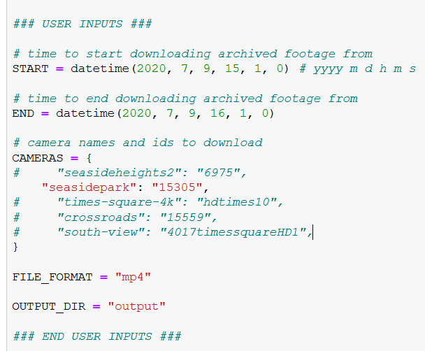

1. Input your start and end times into the python script. Enter the camera info, file format, and output directory.

NOTE: I don’t believe that the camera name or id change, so once you complete this for a single camera, you don’t need to repeat these steps.

1. Run the code. One camera that I tried using this method couldn’t find the URL. It is not a perfect method, but its good when it works.

NOTE: Make sure you have the python dependencies, including ffmpeg.

